**Title Page**

**Project Title:** Responsive Restaurant Landing Page  
**Submitted By:**

* Name: KODANDA RAMA M , Dean joah bell , Thumma Abhijith akshai Reddy
* Roll Number: 2462111 , 2462061 , 2462161
* Email: [m.kodanda@btech.christuniversity.in](mailto:m.kodanda@btech.christuniversity.in) , [dean.joah@btech.christuniversity.in](mailto:dean.joah@btech.christuniversity.in) , thumma.abhijith@btech.christuniversity.in
* **Course:** UI/UX Design Fundamentals  
  **Instructor Name:** Ms.Nagaveena  
  **Institution:** Christ University  
  **Date of Submission:** 13/08/2025

**Abstract**

This project involves designing and developing a fully responsive landing page for a restaurant using HTML5 and CSS3. The primary aim is to create an engaging and visually appealing user interface that showcases the restaurant's brand, menu highlights, location, and contact information. The project focuses on clean layout design, responsive behaviour for multiple devices, and accessibility. Final deliverables include a polished front-end design that reflects the restaurant’s identity and provides an intuitive browsing experience.

**Objectives**

* Design a visually appealing landing page with a strong brand presence.
* Develop a fully responsive layout compatible with desktop, tablet, and mobile.
* Use HTML5 semantic elements for structured content.
* Apply CSS3 styling for typography, layout, and color consistency.
* Ensure fast loading and mobile-first design.

**Scope of the Project**

* Front-end design only; no back-end or server-side functionality.
* Supports desktop, tablet, and mobile devices.
* Pure HTML and CSS without frameworks or libraries.
* Includes sections for Hero Banner, Menu Highlights, About Us, Location Map (placeholder), and Contact Form (non-functional).

| **Tool/Technology** | **Purpose** |
| --- | --- |
| HTML5 | Structure and content layout |
| CSS3 | Styling, colors, responsiveness |
| VS Code | Code editor |
| Chrome DevTools | Testing and debugging |

**HTML Structure Overview**

* **Header:** Restaurant name/logo and navigation menu.
* **Hero Section:** Large background image with tagline and call-to-action.
* **Menu Section:** Highlighted dishes in card format.
* **About Section:** Story of the restaurant.
* **Contact Section:** Form layout for inquiries (placeholder).
* **Footer:** Social links and copyright.

**CSS Styling Strategy**

* External stylesheet with organized sections.
* Flexbox and Grid for layout arrangement.
* Mobile-first approach with media queries for tablet/desktop.
* CSS variables for theme colors.
* Smooth hover effects on menu items and buttons.

**Key Features**

| **Feature** | **Description** |
| --- | --- |
| Responsive Design | Fits all screen sizes seamlessly |
| Hero Banner | Eye-catching full-width image |
| Menu Highlights | Dish cards with images & descriptions |
| Contact Form | Placeholder for future integration |
| Accessible Colors & Fonts | High readability |

**Challenges Faced & Solutions**

| **Challenge** | **Solution** |
| --- | --- |
| Image scaling issues | Used object-fit: cover and responsive sizing |
| Text overlapping on small screens | Applied media queries to adjust font sizes |
| Alignment of menu cards | Switched from float to Flexbox/Grid |

**Outcome**

* Delivered a clean, visually appealing landing page.
* Fully responsive and accessible layout using only HTML and CSS.
* Improved understanding of brand-based UI design principles.

**Future Enhancements**

* Add JavaScript for dynamic features (menu filtering, animations).
* Integrate Google Maps API for live location.
* Implement form validation and backend integration.
* Add a light/dark mode theme toggle.

**Sample Code**

<body>

<header>

<div class="container">

<h1 class="logo">The Golden Spoon</h1>

<nav>

<ul>

<li><a href="#menu">Menu</a></li>

<li><a href="#about">About Us</a></li>

<li><a href="#contact">Contact</a></li>

</ul>

</nav>

</div>

</header>

<section class="hero">

<div class="hero-content">

<h2>Welcome to The Golden Spoon</h2>

<p>Experience exquisite dining in a cozy and elegant atmosphere.</p>

</div>

</section>

<main class="container">

<section id="menu" class="menu-section">

<h2>Our Menu</h2>

<div class="menu-categories">

<h3 class="category-heading">Starters</h3>

<div class="menu-grid">

<div class="menu-item">

body {

font-family: Arial, sans-serif;

margin: 0;

line-height: 1.6;

color: #444;

background-color: #f7f7f7;

}

.container {

max-width: 1100px;

margin: auto;

overflow: hidden;

padding: 0 20px;

}

h2 {

text-align: center;

color: #a87f3b; /* Gold/warm color */

margin-bottom: 40px;

font-size: 2.5rem;

}

**Screenshots of Final Output**

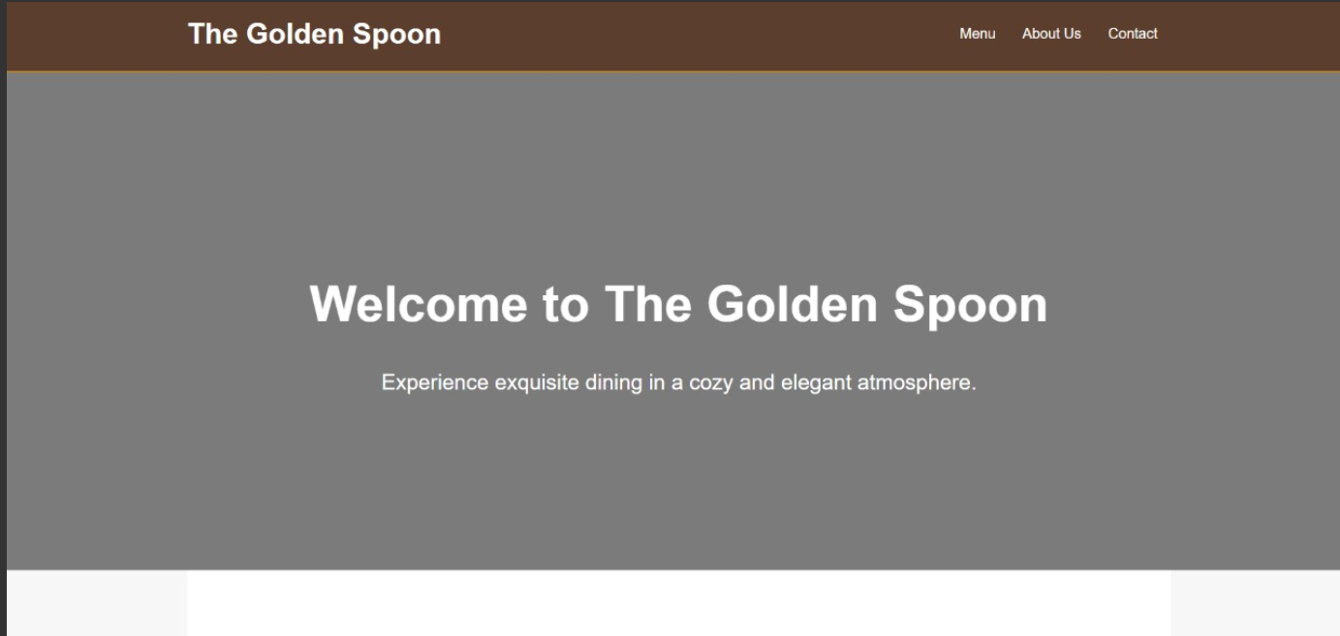

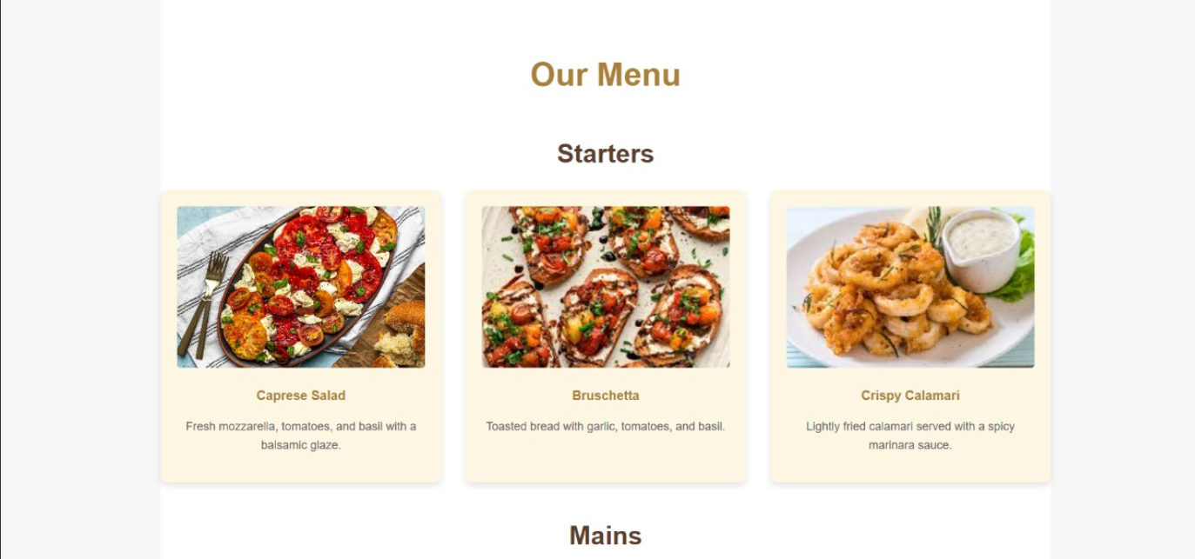

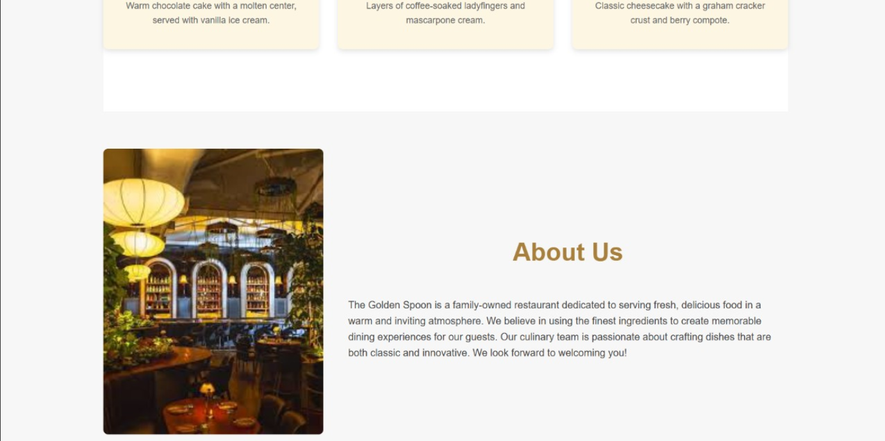

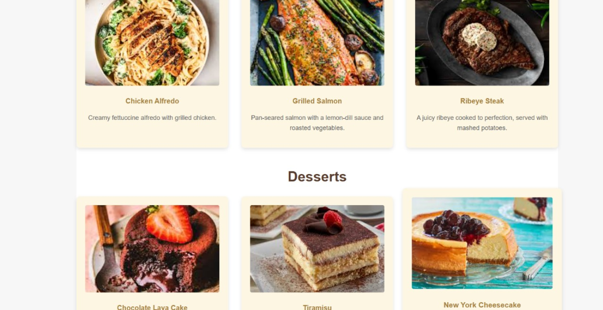

**Conclusion**

This restaurant landing page project enhanced my skills in responsive UI design, typography selection, and layout planning. It helped me apply HTML5 semantics and CSS3 styling effectively while maintaining visual appeal. I also gained insight into how branding influences user perception in web design.

**References**

* L&T LMS: <https://learn.lntedutech.com/Landing/MyCourse>